Literature Response Rubric
Name: |  | Title:
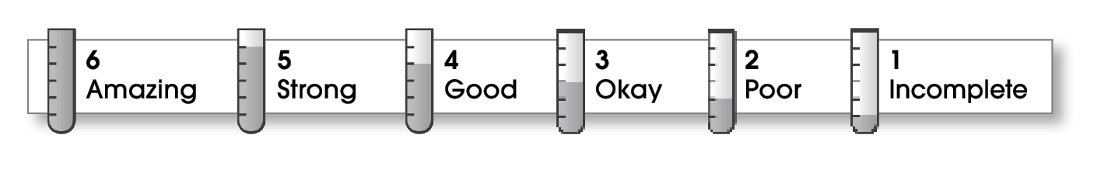

Structure
The writing . . .
- contains an effective beginning, middle, and ending.
- presents a clearly stated focus or opinion statement.
- includes transitions as needed to connect ideas and paragraphs.
Ideas
- reflects the writer’s clear understanding of the literature.
- includes specific details and quotations from the text to develop or support the thesis.
- sounds believable and informed.
- exhibits a careful choice of words.
- flows smoothly from one idea to the next.
Conventions
- follows the standards for punctuation, capitalization, spelling, and grammar.
- cites quotations correctly.

Comments:

© Thoughtful Learning For Writers Express

