Workplace Writing Rubric
Name: |  | Title:
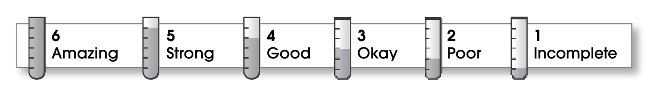

Ideas
The writing . . .
- has a clear, central message.
- provides details that support the central message.
Organization
- begins by capturing the reader’s interest and introducing the message.
- develops the message in the middle paragraphs.
- ends by reviewing the message or making a call to action.
Voice
- sounds knowledgeable and informed.
- speaks in a voice appropriate to the audience.
Word Choice
- uses precise nouns and active verbs.
Sentence Fluency
- uses a variety of sentence lengths and beginnings.
- flows smoothly from one sentence to another.
Conventions
- uses end punctuation and commas correctly.
- correctly capitalizes first words and proper nouns.
- avoids spelling errors.
- correctly uses words (there, they’re, their).
- follows the correct format for the type of message.

Comments:
© Thoughtful Learning For Write on Course 20-20 and All Write

