Teacher Rating Sheet
Name: |  | Title:
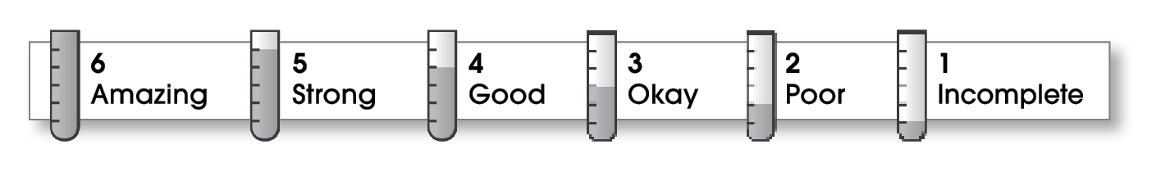

Ideas
Clear and focused  Rich in detail |  |  |  |  |  |  | Fuzzy and disjointed  General, sketch
 | 6 |  | 5 | 4 | 3 | 2 | 1
Organization
Great lead!  Logical order  Clear transitions  Powerful ending |  |  |  |  |  |  | No real lead  Confusing order  Disconnected ideas  No conclusion
 | 6 |  | 5 | 4 | 3 | 2 | 1
Voice
Voice fits purpose  Reaches audience  Cares about topic |  |  |  |  |  |  | Inappropriate voice  Disconnected  Sounds bored
 |  | 6 | 5 | 4 | 3 | 2 | 1
Word Choice
Strong nouns/verbs  Clarifying modifiers  Memorable phrasing |  |  |  |  |  |  | Weak nouns/verbs  Wordy modifiers  Confusing phrases
 |  | 6 | 5 | 4 | 3 | 2 | 1
Sentence Fluency
Easy/fun to read  Varied sentences  Well-crafted ideas |  |  |  |  |  |  | Hard/bad to read  Repetitive  Confusing
 |  | 6 | 5 | 4 | 3 | 2 | 1
Conventions
Correct copy  Attention to detail  Effective design |  |  |  |  |  |  | Error filled  Sloppy  Ineffective design
 |  | 6 | 5 | 4 | 3 | 2 | 1

© Thoughtful Learning For Write on Course 20-20 and All Write

