Explanatory Rubric
Name: |  | Title:
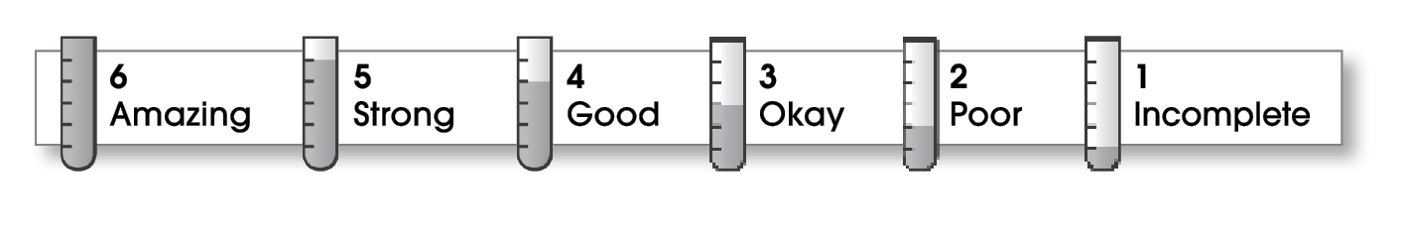

Ideas
The writing . . .
- includes a clear, effective thesis statement.
- provides a variety of interesting details to support it.
Organization
- begins by capturing the reader’s interest and providing the thesis statement.
- has an effectively organized middle.
- focuses on one main point for each middle paragraph.
- ends by summarizing the ideas and giving the reader a final thought.
Voice
- has a voice that shows knowledge of the topic.
- has a voice that engages the reader.
Word Choice
- uses precise nouns and active verbs.
Sentence Fluency
- uses a variety of sentence lengths and beginnings.
- flows smoothly from one sentence to another.
Conventions
- uses end punctuation and commas correctly.
- correctly capitalizes first words and proper nouns.
- avoids spelling errors.
- correctly uses words (there, they’re, their).

Comments:

© Thoughtful Learning For Write on Course 20-20 and All Write

